**Project Initialization and Planning Phase**

| Date | June 2024 |
| --- | --- |
| Team ID | 739971 |
| Project Name | Estimating the stock keeping units using Machine Learning |
| Maximum Marks | 3 Marks |

### Define Problem Statements(Customer Problem Statement Template):

Create a problem statement to understand your customer's point of view. The Customer Problem Statement template helps you focus on what matters to create experiences people will love. A well-articulated customer problem statement allows you and your team to find the ideal solution for your customers' challenges. Throughout the process, you’ll also be able to empathize with your customers, which helps you better understand how they perceive your product or service.

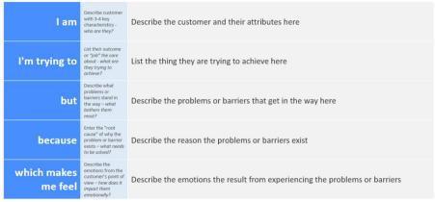

Reference: https://miro.com/app/board/uXjVK2aqlmY=/?share_link_id=534024970903

**Example:**

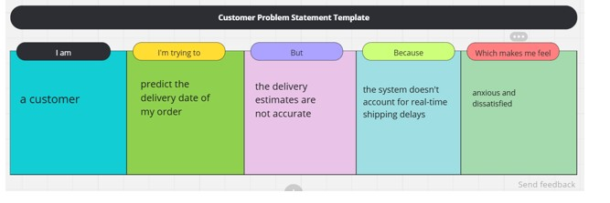

| **Problem**  **Statement (PS)** | **I am** | **I’m trying to** | **But** | **Because** | **Which makes me feel** |
| --- | --- | --- | --- | --- | --- |
| PS-1 | customer | Predict the stock units of my stock | The stock estimate are not accurate | The system doesn't account for real-time SKUs delays | Anxious and dissatisfied |
| PS-2 | a stakeholder | make sure SKUs predicted successfully | the SKUs estimates are unavailable | the system doesn’t account for holidays or peak times | worried and disappointed |